***UNIVERSITY OF PETROLIUM AND ENERGY STUDIES***

*P.O Bidholi, Via-Prem Nagar, Dehradun-248007*

*RESEARCH PAPER*

**Data Communication and Computer Networks**

**Session-2022-23**

**

*Topic: Implementation of School Networking System*

***Submitted By****:*

*Hitendra Sisodia 500091910*

*Priyanshu Tandon 500091901*

*Ujesh Sisodia 500091882*

*Kartikay Kanojia 500090998*

*Anirudh Srinivasan 500091739*

**Abstract**

School Networking System is a project which aims in developing a prototype of the actual network system that is installed in school labs and offices for learning and ease purposes.

It gives the exact scenario of how different routers, switches, PC's etc are connected with each other to form a giant network so that data can be easily communicated along the whole school network. We used Cisco Packet Tracer o summarise the whole project so that it easily demonstrates the functions of each device used and if errors (if any) are found in between the data communication.

**Chapter – 1(Introduction)**

**1.1 Introduction**

This chapter gives an overall view about the aim, objectives, background of the system.

1.1 Project Aims and objectives

Right from the day of computer automation, a computer has developed computer in each department. For example, the task can be to keep of track off inventories, monitor productivity and maintain accounts. Initially, this computer in different department works as an isolation from other computer. These provided the necessary computer assistance in the activities pertaining to the respective department. It was not possible to share information among the departments. As a result, the information was replicated wherever needled. This increased redundancy caused increased in storage space, less data consistency etc.

Hence, at a point it was decided to connect the computers in various departments to extract the information and correlate information about the entire company. The following are the objectives of the computer networks.

1. Resource sharing is the main objective of the computer network. The goal is to provide all the program, date and hardware is available to everyone on the network without regard to the physical location of the resource and the users.

2. The second objective is to provide the high Reliability. It is achieved by replicating the files on two or more machines, so in case of unavailability (due to fail of hardware) the other copies can be used

3. Computer organization has helped organization in saving money. This is due to the fact that the small computer has much better price to the performance ratio comparison than the large computer like mainframe. Mainframe computer are approximately ten times faster than the microcomputers, but they cost thousands times more. As a result of this Imbalance, organization has preferred to install interconnected microcomputer connected to the mainframe computer.

4. Computer network have provided means to increase system performance as the work load increases (load balancing) In the days of mainframe when the system was fall it was to replace with the other large mainframe computers, usually at and expensive rate not convenience for user.

5. Computer network help people who live or work apart to reject together. So, when one uses prepared some documentation, he can make the document online enabling other to read and convey their option. Thus, comparer network is a powerful communication medium

6. Only authorized user can access resource in a computer network. Users are authenticated by their user name and password. Hence it is not possible to access the data without proper account. This increases security.

**1.2 Background of project**

The base of this working system lies in the need to establish a giant network out only in schools but at every workplace that has a large use of internet facilities. In this modern era of digitalization networking systems have become a need.

A computer network is defined as interconnected collection of autonomous computers Computer are said to be interconnected, if they, able to exchange information Connection is physically established through cables, lasers, microwaves, fibre optics and communication satellite.

What we mean by the word “Autonomous”? Autonomous is any one computer in the network that cannot forcibly start, stops or control another computer in the network. In other words, the computer works independently. This is sharp contrast to a computer with full control over many slaves. This is not a computer network.

Now there is another term ‘distributed computing’ which is closely related with network. A distributed computer system differs from a computer network in one as aspect that in a distributed system, the existence of multiple autonomous computers is not visible to the user. The user can type commands that are executed in a different machine selected by the operating systems. It is the job of the operating system to select fire processor, find and move all the required Input files to that processor and send the result to the user.

In a network, the user must login to the network, locate files and submit jobs. The network management has to be handled personally by the user. Io a distributed system, all jobs are done automatically try the system with the user's knowledge fence the distributed system in a special Use of network system, whine operating system has a high degree of transparency.

**Chapter 2(System Analysis)**

In this, chapter we will discuss and analyze about the developing process of network system including software requirement specification and comparison between existing and proposed system. Existing versus proposed provides a view of how the proposed system will be more efficient than the existing one.

2.1 Software Requirement Specification

2.1.1 General Description

School networking System is a system which helps you to manage the learning labs offices and all the systems that requires the network use. A prototype of a giant network is always necessary to build before the actual establishment to avoid errors.

**2.2 Software and Hardware Requirement**

This section describes the software and hardware requirements of the system:

**2.2.1 Software Requirement**

* Operating system windows 10 Pro is used as the operating system as it is stable and supports more features and is more user friendly.
* CISCO PACKET TRACER is used as the main software to design the whole network.

**2.2.2 Hardware Requirement**

* Intel core i5 is used as the processor because it is fast than other processors.

**Chapter 3 (System Implementation)**

Screenshot of the project

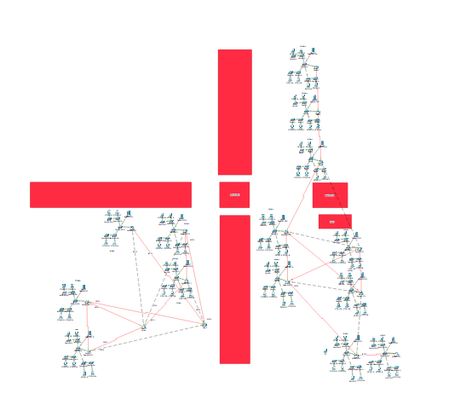

**Chapter 4 (System testing)**

In this chapter, we will discuss the objectives covered, and the network which is working properly and which objectives were not fulfilled.

4.1 Covered Objectives

Following are the Objectives which have been covered and are working properly:

* Data Communication between all the computers.
* No errors between communication
* Proper working of routers and switches
* Easy access to internet facility at all PC's.

**Chapter 5 (Conclusion and future work)**

**5.1 Future Work**

The School Network System has become a necessity in this era of digitalization. A school in today's world simply can't run without a proper networking system that allows exceptional data communication across the whole campus that is fluent in nature and is flawless in terms of its speed, easy access etc.

**5.2 Conclusion**

This school networking system is designed on cisco packet tracer with the key objectives of understanding and implementing all the necessary data communication formulas that are exceptionally necessary to run a school. The routers providing full and overall access to the network, switches working properly as per they are set, and minimizing every flaw possible, this prototype of a school network system is ready to be implemented in schools.

To Design the network outlook for the school network scenario produces the substructure for all other exposure in the service framework such as security of the network, wireless area network, mobility as can apply these scenarios within the various locations of a community college network. Finally, key well as putting the justification to provide safety and security, operational efficiencies, virtual learning environments, and secure classrooms. This project describes the network design scenario where we can apply these scenarios within the various location of a community college network. Finally, key network foundation services such as switching, routing, multicast, and high availability are given for the full school network scenario.

**References**

1. Lee, J. K., & Kim, J. H. (2017). Design and Implementation of School Networking System for Smart Education Environment. International Journal of Software Engineering and Its Applications, 11(3), 17-28.
2. Zhang, X., & Ma, J. (2019). Research and Implementation of a Campus Network System Based on SDN Technology. Journal of Physics: Conference Series, 1240(1), 012080.
3. Vidal, J., Durán, J. J., & Vega-Rodríguez, M. A. (2018). Design and Implementation of a School Networking System based on Raspberry Pi. International Journal of Interactive Multimedia and Artificial Intelligence, 5(5), 12-16.
4. Designing and Deploying 802.11 Wireless Networks: A Practical Guide to Implementing 802.11n and 802.11ac Wireless Networks for Enterprise-Based Applications" by Jim Geier
5. CompTIA Network+ Certification All-in-One Exam Guide, Seventh Edition (Exam N10-007)" by Mike Meyers